Technical Architecture Deep Dive
True sequence diagrams, scoring framework, and implementation notes for the EV battery supply-chain intelligence platform
Context | Backend-first ingestion platform using FastAPI, workers, Postgres, and scheduled jobs.
Focus of this version | Operational sequence diagrams, score construction, rollups, failure handling, and report-serving path.

This document is based on the architecture and platform requirements in your Cursor backend build brief: a reports-first ingestion foundation with Phase 1 source ingestion, normalization, rule-based scoring, internal APIs, and future SaaS evolution.

1. Design intent and operating model
The architecture should stay simple in the request path and deliberately move heavyweight work into workers. The frontend remains thin: it requests report-ready data from FastAPI, while ingestion, parsing, entity resolution, and score refreshes happen asynchronously.
- Frontend: Next.js on Vercel for dashboards, reports, and future authenticated SaaS views.
- API: FastAPI on Render web service for internal/public endpoints and report-serving.
- Execution: Render background worker(s) for ingestion, parsing, normalization, scoring, and report builds.
- Scheduling: Render cron jobs for recurring source pulls and nightly recomputation.
- Persistence: Neon Postgres for structured state, plus R2 or S3 for raw payloads and evidence artifacts.
Operational principles
- Every ingestion run gets a durable run record before network work begins.
- Every raw payload is stored before irreversible parsing or normalization.
- All downstream writes are idempotent through natural keys and checksums.
- Scores are explainable and stored with rationale_json rather than hidden model state.
- The frontend never talks directly to Neon; it only consumes the API layer.
2. Core service topology
Layer | Primary service | Reason it belongs there
Presentation | Vercel / Next.js | Best fit for UI, previews, SSR, and future auth-driven dashboards.
Application | Render / FastAPI | Holds endpoints, orchestration triggers, response composition, and internal admin APIs.
Execution + storage | Render workers + cron, Neon, R2/S3 | Matches asynchronous ingestion, durable relational state, and cheap raw evidence retention.
3. True sequence diagrams
The diagrams below represent the main execution paths that matter once the frontend is added and the platform begins operating continuously.
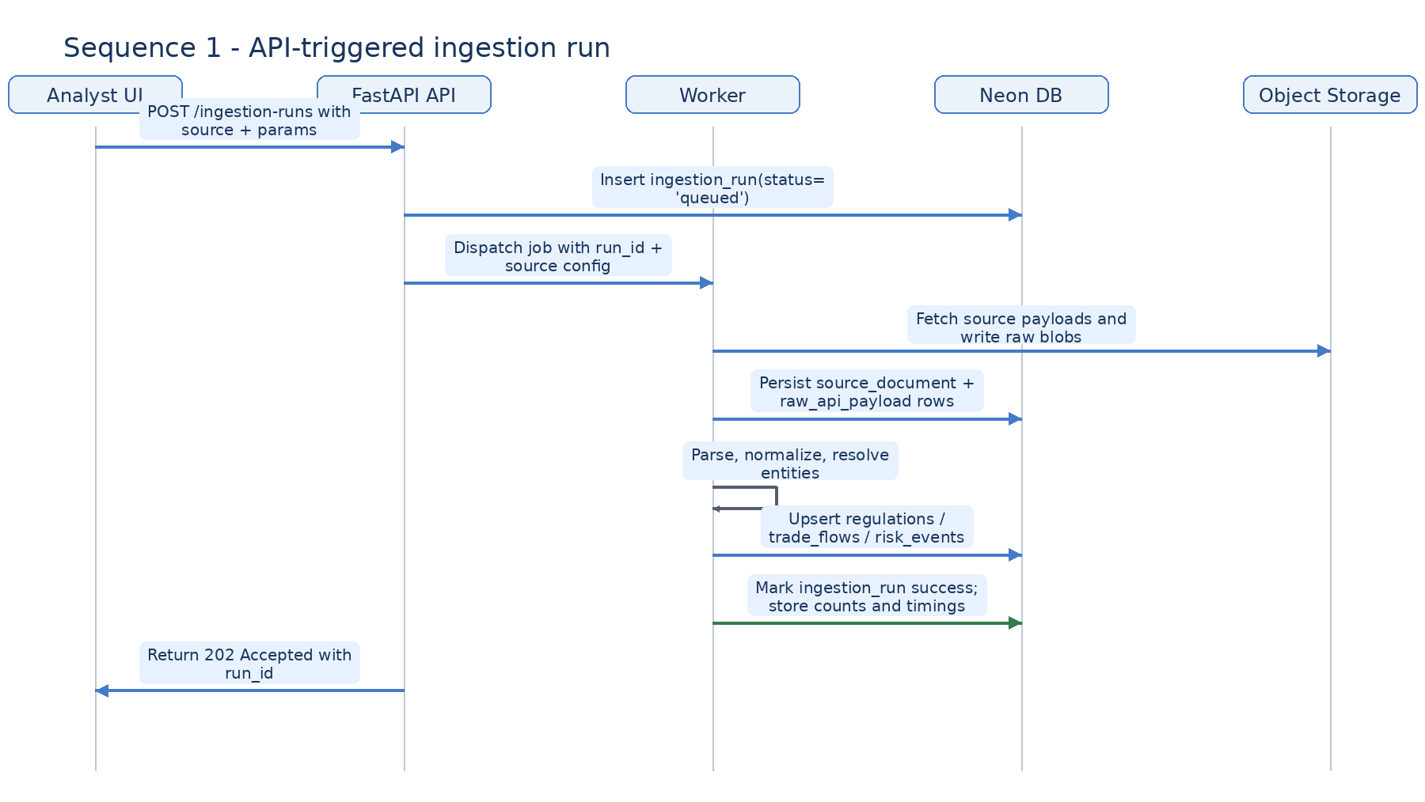
Figure 1. API-triggered ingestion run
What matters in this path
- The API returns immediately after queueing work, which keeps request latency predictable.
- The worker owns the expensive part: pagination, blob storage, parsing, and normalized writes.
- The run row in Neon becomes the source of truth for dashboards and troubleshooting.
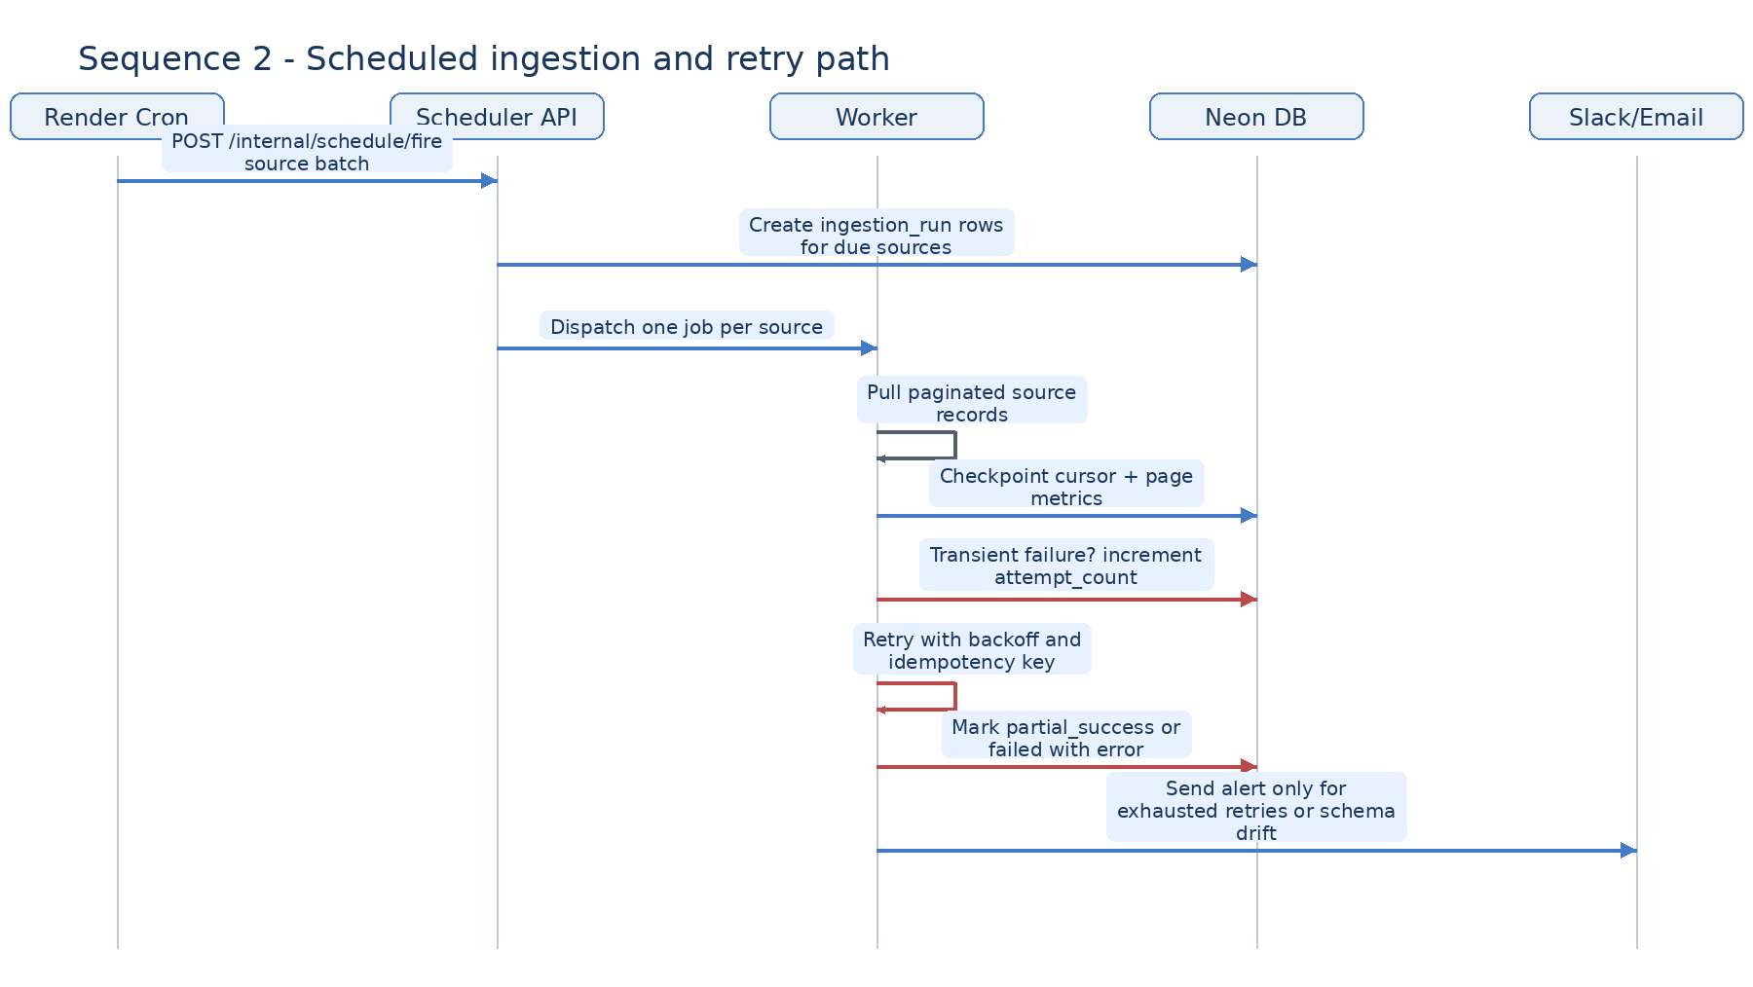
Figure 2. Scheduled ingestion with retry and alerting
Recommended retry policy
Failure class | Examples | Treatment | Escalate?
Transient I/O | 429, 5xx, timeout | Retry 3-5x with exponential backoff and jitter | Only after max attempts
Source drift | field renamed, schema shape break | Mark failed, retain payload, emit parser alert | Yes, immediately
Duplicate replay | same page, same accession, same checksum | No alert; idempotent upsert or skip | No
Partial batch | one page bad, others fine | Commit partial results and mark partial_success | Yes, low urgency

4. Sequence details by path
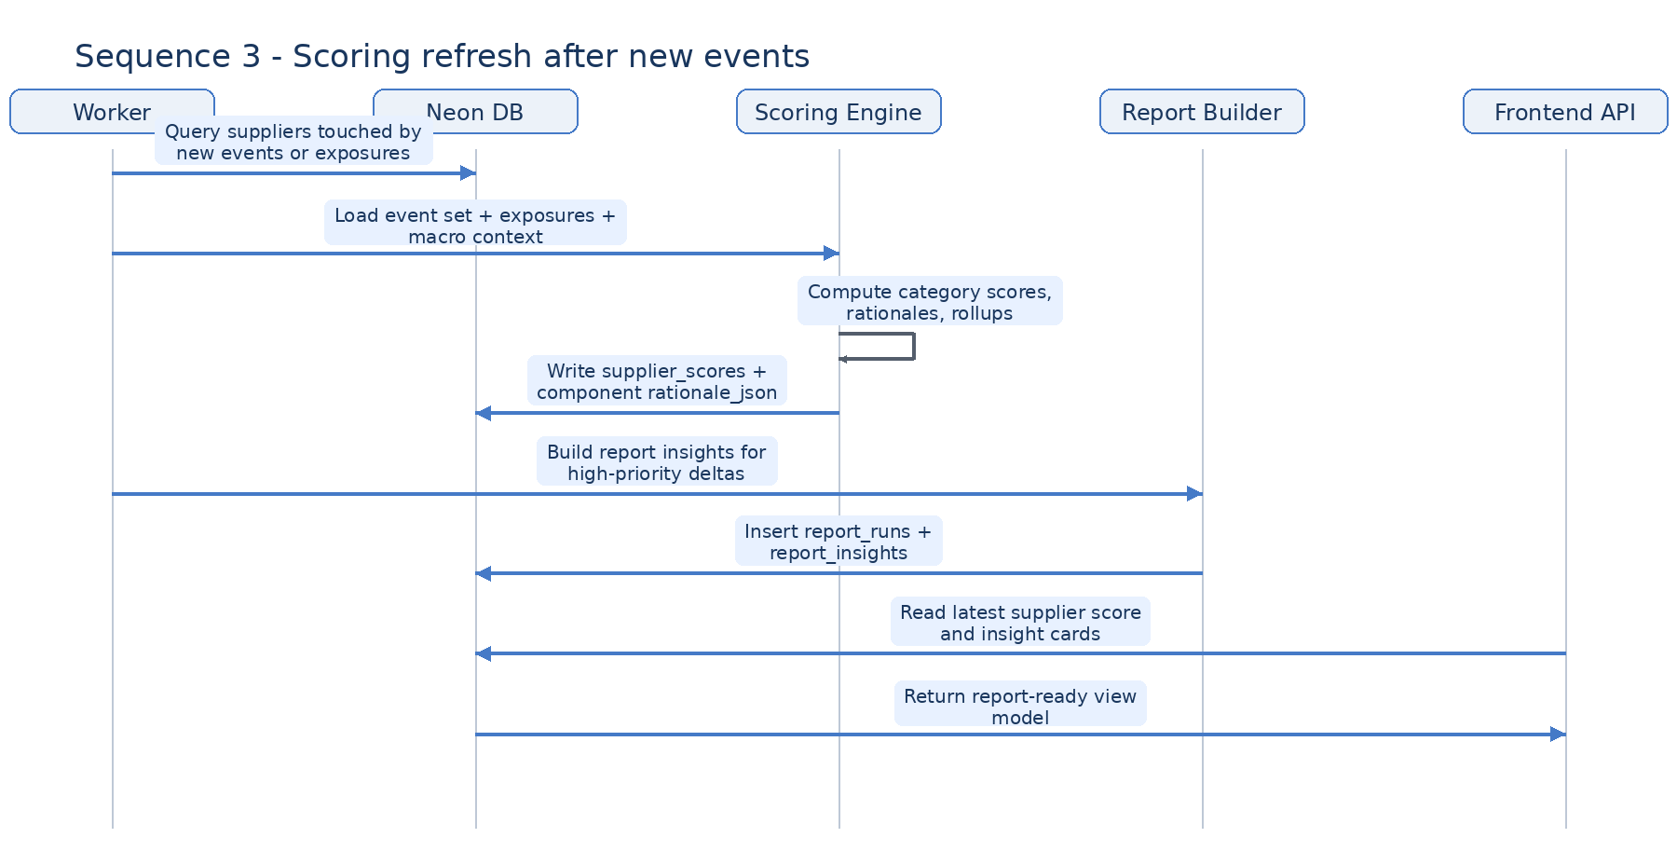
Figure 3. Score refresh and report insight generation
Scoring refresh contract
- Any supplier touched by a new event, exposure change, filing update, or trade-flow shock is eligible for refresh.
- The scoring engine should load only the evidence window it needs, not the entire document history.
- A score refresh writes both numeric components and rationale_json so the UI can explain deltas without recomputing them live.
- Report insights are generated after score persistence so every insight can reference a stable score snapshot.
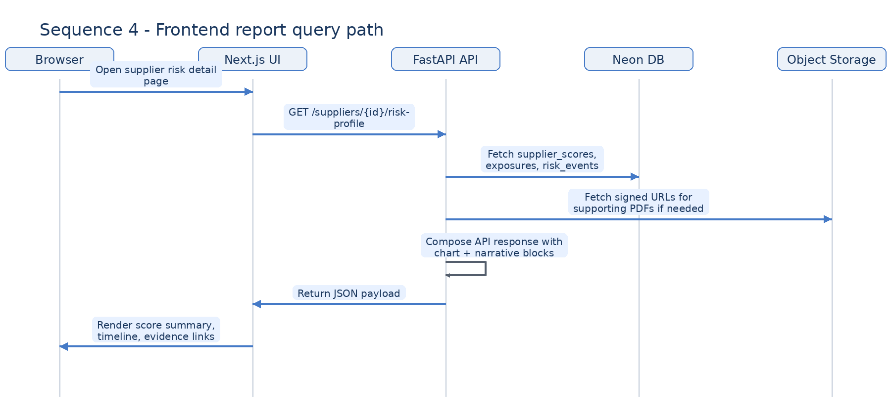
Figure 4. Frontend report query path
Frontend response composition
- The API should aggregate charts, summary text, and evidence links into one response model per page.
- Signed file URLs should be short-lived and created on demand rather than stored directly in the DB.
- Where possible, high-cost evidence joins should be precomputed into report_insights for fast page loads.
5. Scoring philosophy
The scoring system should be transparent, explainable, and deliberately conservative. The goal is not to predict an exact future outage; it is to rank suppliers and exposures by combined evidence strength so analysts and report consumers can see where attention is most justified.
- Use stable 0-100 scales for each component.
- Keep the first version rule-based and auditable.
- Store both the final score and the evidence that produced it.
- Separate event scoring from supplier-level rollup logic.
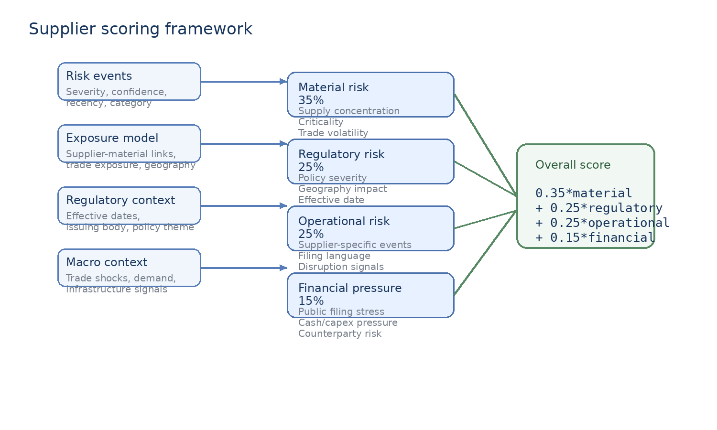
Figure 5. Component score stack and weighted rollup
6. Event scoring mechanics
Before rolling up to a supplier score, individual risk events should be normalized into a comparable event impact value. This lets you mix regulations, news, filing-derived distress signals, and market disruptions in one evidence stream.
event_impact = severity × confidence × recency_multiplier × relevance_multiplier

Suggested component definitions
Factor | Range | Example default | Notes
severity | 0-1 | 0.85 | How materially disruptive the event is if true.
confidence | 0-1 | 0.70 | Strength of evidence and parser certainty.
recency multiplier | 0.60-1.20 | 1.00 | Recent items retain more weight; old items decay.
relevance multiplier | 0.70-1.30 | 1.10 | Higher when event geography, material, or supplier match is direct.
Example event impacts
Event type | Severity | Confidence | Impact | Interpretation
Critical mineral export restriction | 0.90 | 0.85 | 0.92 | Strong policy shock with direct supply relevance.
Supplier warns of margin pressure in 10-Q | 0.60 | 0.80 | 0.58 | Important but indirect operational stress.
Trade-flow decline in relevant HS code | 0.70 | 0.65 | 0.61 | Useful macro signal; confidence depends on mapping quality.
Generic industry news mention | 0.30 | 0.45 | 0.23 | Evidence exists, but low directness and lower signal strength.

7. Supplier-level component scores
Supplier scores should be computed from evidence windows rather than single events. Each category score consumes a different subset of the evidence graph.
Category | Weight | Primary inputs | Rollup logic
Material risk | 35% | Material exposures, criticality, trade volatility, concentration | Weighted average by supplier_material_exposure and material criticality.
Regulatory risk | 25% | Regulations, effective dates, policy geography, issuing body | Top-k event impacts with an uplift for near-term effective dates.
Operational risk | 25% | Supplier-specific disruptions, news, filing language, production interruptions | Blend of recent supplier events with decay and duplicate clustering.
Financial pressure | 15% | Public filings, liquidity language, capex cuts, covenant stress | Low-frequency but high-importance signals; cap the score when evidence is weak.
Recommended first-pass formulas
Material risk | score = min(100, 45*criticality + 30*trade_volatility + 25*concentration)
Regulatory risk | score = min(100, sum(top_3 regulatory event impacts * policy_proximity_adjustment))
Operational risk | score = min(100, weighted_sum(recent supplier event impacts with 90-day half-life))
Financial pressure | score = min(100, base_filing_signal + leverage_warning_bonus + liquidity_stress_bonus)
Overall score rollup
overall_risk_score = 0.35*material + 0.25*regulatory + 0.25*operational + 0.15*financial
Practical note: keep the raw unrounded component values in rationale_json and round only for presentation. That prevents drift when the UI shows score deltas over time.
8. Recency decay and evidence windows
A clean scoring system becomes much more believable when old evidence fades gracefully instead of disappearing abruptly. Use category-specific evidence windows and simple decay functions.
Evidence family | Window | Decay suggestion | Reason
Regulations | 365 days before and after effectivity | Step-up inside 90 days before effective date | A policy becomes more actionable as enforcement approaches.
Trade flows | 12 months | Monthly smoothing, then compare latest 3 months vs prior baseline | Trade shocks are noisy and need baseline context.
Supplier events | 180 days | 90-day half-life | Operational incidents go stale, but not instantly.
Financial filing signals | 4 most recent quarters | Hold until superseded by a newer filing | Public filings are sparse but important.

9. Worked scoring example
Example supplier: a cathode active material producer with high nickel exposure, new regulatory pressure on a source geography, and mild financial stress language in its latest filing.
Component | Raw inputs | Score | Weight | Weighted contribution
Material risk | criticality .90; trade vol .70; concentration .80 | 81 | 0.35 | 28.35
Regulatory risk | two direct regulations; one effective in 45 days | 73 | 0.25 | 18.25
Operational risk | recent disruption article; no production halt | 58 | 0.25 | 14.50
Financial pressure | cautious capex language in 10-Q | 42 | 0.15 | 6.30
Result: overall risk score = 67.4, which is high enough to surface in reports but not yet in the most severe watchlist tier.
Suggested severity bands
Band | Range | Meaning
Low | 0-34 | Monitor only; not a headline report topic.
Moderate | 35-54 | Worth noting where exposure is material or trend is worsening.
High | 55-74 | Should appear in supplier and investor reports with rationale.
Critical | 75-100 | Escalate to priority watchlist and lead with supporting evidence.
10. What to persist in the database
- risk_events: normalized event record, category tags, geography_json, severity_score, confidence_score, evidence metadata.
- supplier_material_exposure: persistent exposure links and exposure_score so material risk can be computed without re-deriving the graph on every read.
- supplier_scores: one row per supplier and as_of_date, containing component scores, overall score, and rationale_json.
- report_runs and report_insights: report-ready denormalization so the frontend can render insight cards quickly.
Recommended rationale_json shape
Key | Contents
inputs | Supplier id, evidence window, scoring version, run id
components | Exact raw values and final component scores
top_evidence | Top event ids or document ids that moved the score
decay | Applied recency parameters and evaluation date
notes | Human-readable explanation string for UI or analysts
11. Implementation guidance
- Keep scoring as a pure service layer: inputs in, score package out. Persist after computation, not during it.
- Version the scoring logic. A simple scoring_version string in supplier_scores and rationale_json is enough to start.
- Avoid recomputing every supplier every run. Refresh only suppliers touched by new evidence or changed exposures.
- Cluster near-duplicate events before operational rollup so one article syndicated across many outlets does not overwhelm the score.
- Write deterministic tests around formulas, decay, and threshold behavior before adding AI summarization on top.
12. Recommended next build steps
- Add explicit endpoints for /ingestion-runs/{id}, /suppliers/{id}/risk-profile, and /reports/{type}/{run_id}.
- Persist attempt_count, started_at, completed_at, and checkpoint metadata on ingestion_runs for cleaner operational dashboards.
- Store one compact score breakdown object per supplier page so the frontend can render chart segments without extra joins.
- Introduce Redis only after you need distributed locks, short-term caching, or more coordinated queue behavior.
Appendix A. Sequence implementation checklist
Area | Must-have behavior | Why it matters
API queueing | Return 202 after creating run row | Makes UI responsive and stateful
Raw storage | Store payload before parse | Supports replay and parser debugging
Idempotency | Upsert using source natural keys | Prevents duplicate events and documents
Retries | Retry only transient failures | Keeps noise low and runs understandable
Scoring refresh | Recompute touched suppliers only | Limits cost and runtime
Report serving | Use report-ready view models | Keeps frontend simple

